# Final Project Part 1 (Assignment 3)

## Project Description

This project is a homework assignment to teach how to get Pycharm setup with Docker, Flask, MySQL, and Postman. Form screenshots are here.

## a.) Project Schema and Data in PyCharm

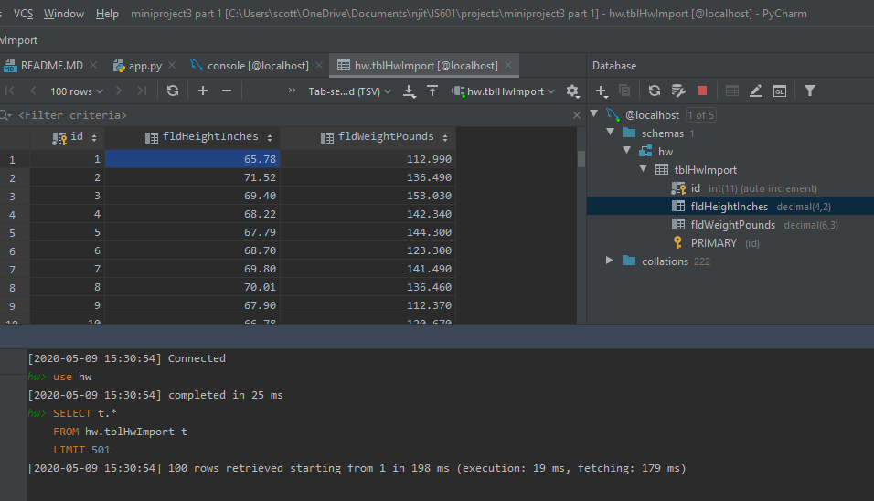

## b.) Homepage with data

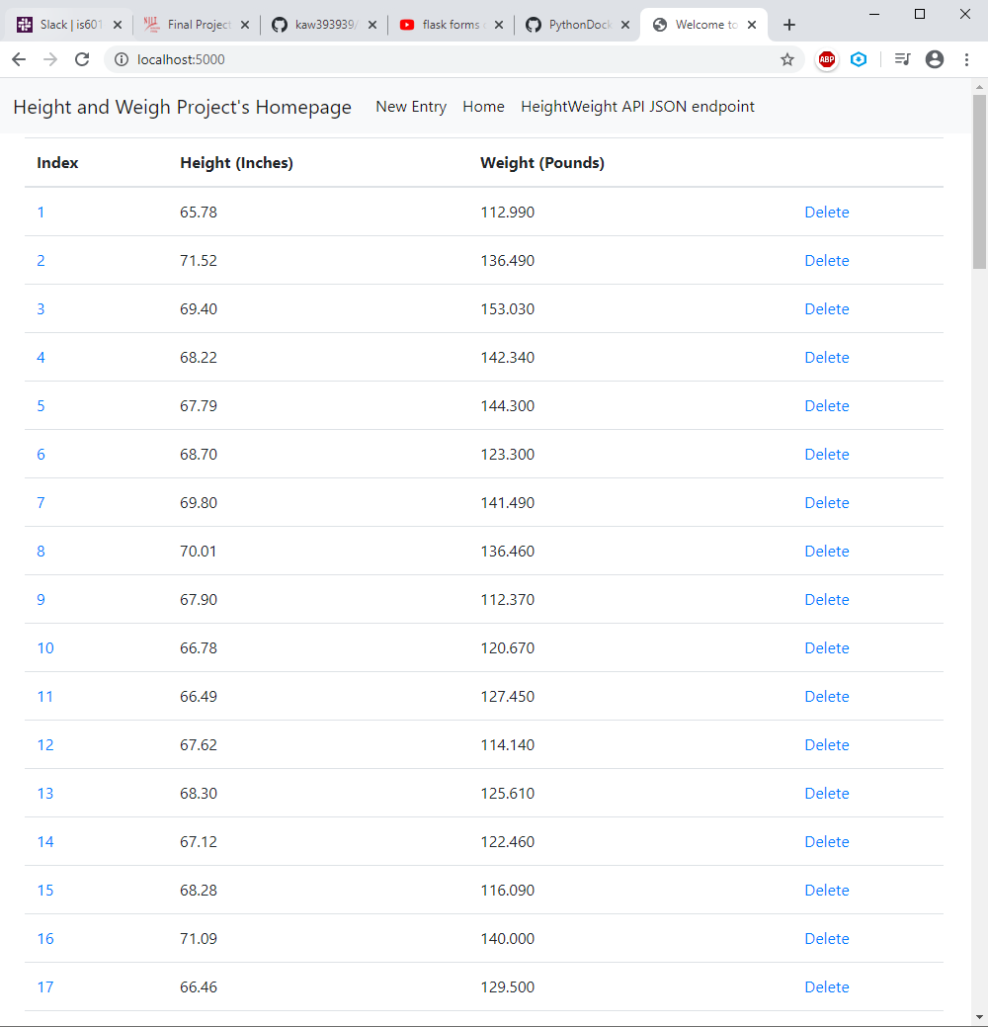

## c.) View of one record

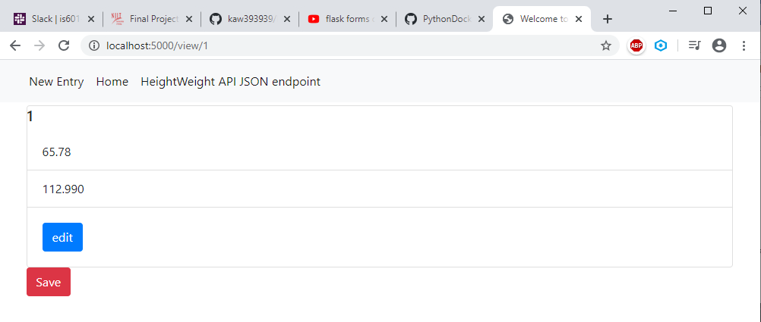

## d.) New Record Added (101)

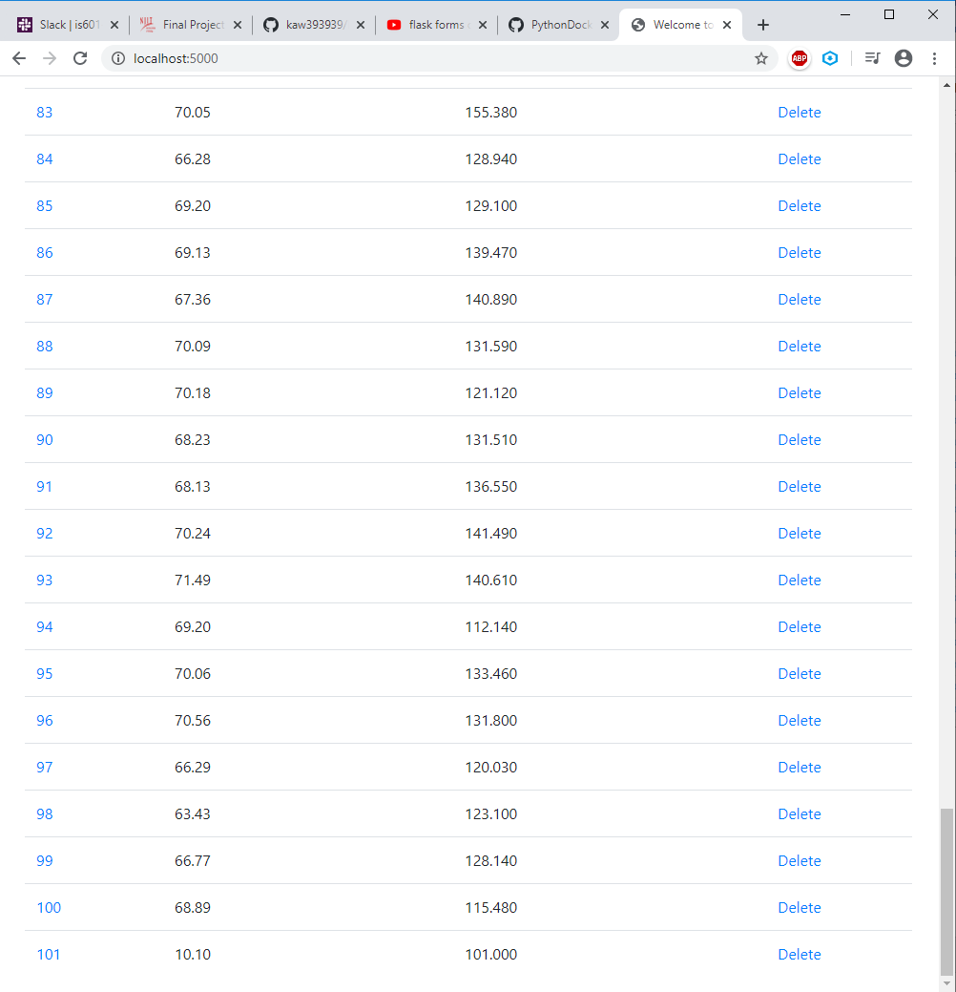

## e.) Record 101 Updated

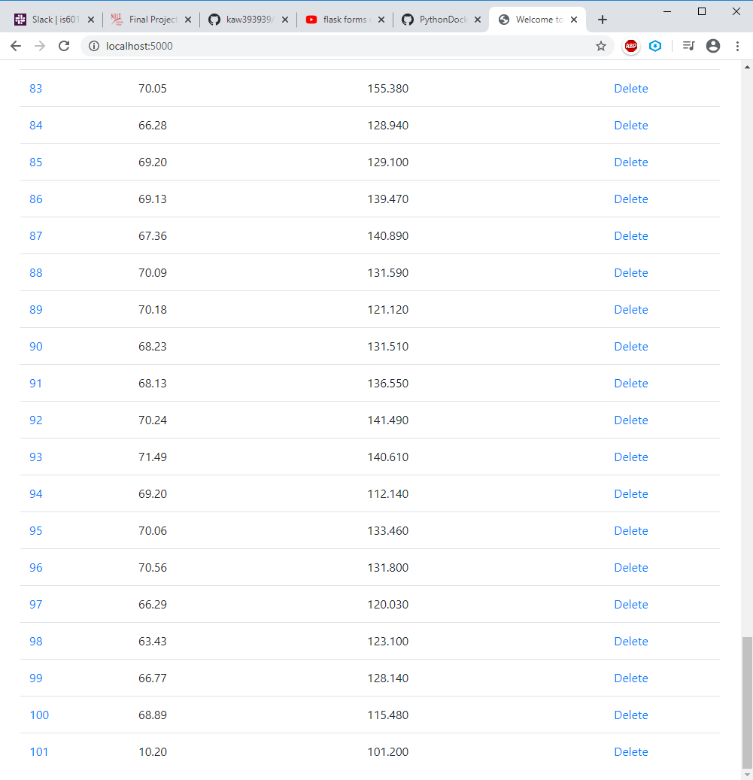

## f.) Record 101 Deleted

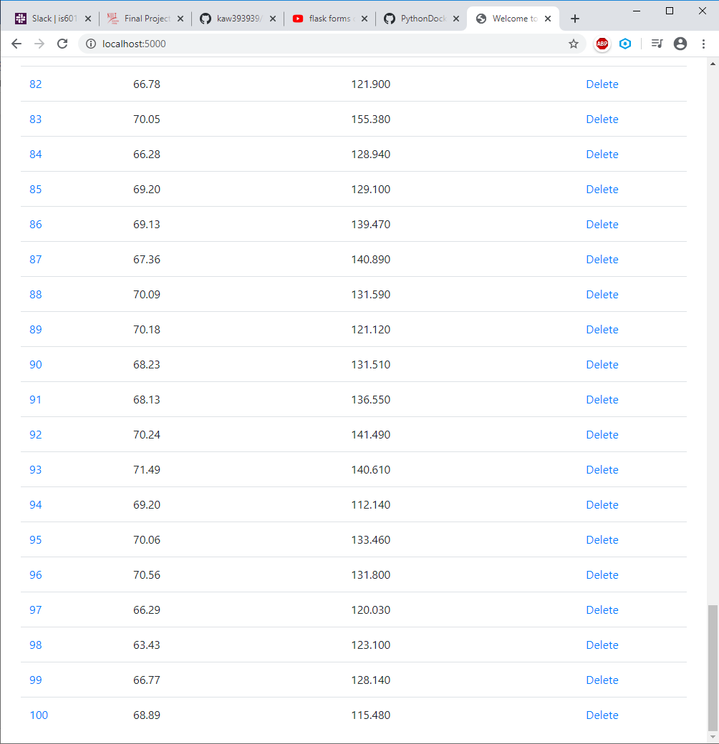

## Author

Scott Grodberg

## Changelog

* 5/4/20 Clone repo, checkout lesson3, initial commit
* 5/4/20 Set up docker containers
* 5/4/20 Data import
* 5/4/20 Index page
* 5/4/20 View page
* 5/4/20 Edit page
* 5/4/20 Edit page save
* 5/4/20 New page
* 5/4/20 New page save
* 5/4/20 Delete action
* 5/4/20 APIs
* 5/4/20 Link to new form